Topic 11
Dynamic Programming – Graph Algorithms
Bellman-Ford, Floyd-Warshall, Warshall's Algorithm
Dr. Mary Harin Fernandez F

1. Bellman-Ford Algorithm
Given a weighted directed graph and a source vertex, find the shortest distance from the source to all other vertices using the Bellman-Ford algorithm. If the graph contains a negative weight cycle, report it.

Example 1:
Input:
Vertices = 5
Edges = [(0,1,-1),(0,2,4),(1,2,3),(1,3,2),(1,4,2),(3,2,5),(3,1,1),(4,3,-3)]
Source = 0
Output:
Vertex Distance
0 0
1 -1
2 2
3 -2
4 1

Example 2:
Input:
Vertices = 3
Edges = [(0,1,1),(1,2,-1),(2,0,-1)]
Source = 0
Output:
Negative Weight Cycle Detected

2. Floyd-Warshall Algorithm
Given a weighted graph represented by an adjacency matrix, find the shortest distances between every pair of vertices using the Floyd-Warshall algorithm.

Example 1:
Input:
[
[0,5,INF,10],
[INF,0,3,INF],
[INF,INF,0,1],
[INF,INF,INF,0]
]
Output:
[
[0,5,8,9],
[INF,0,3,4],
[INF,INF,0,1],
[INF,INF,INF,0]
]

Example 2:
Input:
[
[0,2,INF],
[INF,0,4],
[1,INF,0]
]
Output:
[
[0,2,6],
[5,0,4],
[1,3,0]
]

3. Warshall's Algorithm
Given a directed graph represented by an adjacency matrix, determine whether a path exists between every pair of vertices. Compute the transitive closure of the graph using Warshall's algorithm.

Example 1:
Input:
[
[0,1,0,0],
[0,0,1,0],
[0,0,0,1],
[0,0,0,0]
]
Output:
[
[0,1,1,1],
[0,0,1,1],
[0,0,0,1],
[0,0,0,0]
]

Example 2:
Input:
[
[0,1,1],
[0,0,1],
[1,0,0]
]
Output:
[
[1,1,1],
[1,1,1],
[1,1,1]
]

4. Find the City with the Smallest Number of Reachable Cities
Given a weighted graph and a distance threshold, find the city that can reach the smallest number of other cities within the threshold distance. Use Floyd-Warshall algorithm to compute all-pairs shortest paths.

Example 1:
Input:
n=4
edges=[[0,1,3],[1,2,1],[2,3,4],[0,3,7]]
threshold=4
Output:
3
Explanation:
City 3 can reach the fewest cities within the given threshold distance.

Example 2:
Input:
n=5
edges=[[0,1,2],[0,4,8],[1,2,3],[1,4,2],[2,3,1],[3,4,1]]
threshold=2
Compute reachable cities within distance ≤ 2:

Output:
0

5. Network Delay Time
A signal is sent from a source node to all nodes in a network. Find the minimum time required for all nodes to receive the signal using the Bellman-Ford algorithm. Return -1 if some nodes cannot be reached.

Example 1:
Input:
times=[[2,1,1],[2,3,1],[3,4,1]]
n=4
k=2
Output:
2
Explanation:
The signal reaches all nodes in 2 units of time.

Example 2:
Input:
times=[[1,2,1]]
n=2
k=2
Output:
-1

6. Cheapest Flight Within K Stops
Given a list of flights represented as (source, destination, cost), find the minimum cost to travel from the source city to the destination city with at most K stops using the Bellman-Ford algorithm.
Example 1:
Input:
n = 4
flights = [[0,1,100],[1,2,100],[2,3,100],[0,3,500]]
src = 0
dst = 3
K = 1
Output:
500
Explanation:
The route 0→1→2→3 requires 2 stops and is not allowed.

Example 2:
Input:
n = 4
flights = [[0,1,100],[1,2,100],[2,3,100],[0,3,500]]
src = 0
dst = 3
K = 2
Output:
300
Explanation:
The route 0→1→2→3 costs 300 and uses exactly 2 stops.

7. Detect Negative Weight Cycle
Given a weighted directed graph, determine whether it contains a negative weight cycle using the Bellman-Ford algorithm.
Example 1:
Input:
Vertices = 4
Edges = [(0,1,1),(1,2,-1),(2,3,-1),(3,0,-1)]
Output:
Negative Weight Cycle Exists
Explanation:
The cycle weight is 1 + (-1) + (-1) + (-1) = -2.

Example 2:
Input:
Vertices = 4
Edges = [(0,1,4),(0,2,5),(1,2,-2),(2,3,3)]
Output:
No Negative Weight Cycle

8. Determine Reachability Between Two Vertices
Given a directed graph represented as an adjacency matrix and two vertices u and v, determine whether a path exists from u to v using Warshall's Algorithm.
Example 1:
Input:
Graph =
[
[0,1,0],
[0,0,1],
[0,0,0]
]
u = 0
v = 2
Output:
Path Exists
Explanation:
A path exists from 0 to 2 through vertex 1.

Example 2:
Input:
Graph =
[
[0,1,0],
[0,0,0],
[1,0,0]
]
u = 1
v = 2
Output:
Path Does Not Exist

9. Count Reachable Vertices from a Source
Given a directed graph represented by an adjacency matrix, find the number of vertices reachable from a specified source vertex using the transitive closure generated by Warshall's Algorithm. Do not count the source vertex itself.
Example 1:
Input:
Graph =
[
[0,1,0,0],
[0,0,1,0],
[0,0,0,1],
[0,0,0,0]
]
Source = 0
Output:
3
Explanation:
Vertices 1, 2, and 3 are reachable from vertex 0.

Example 2:
Input:
Graph =
[
[0,1,1],
[0,0,1],
[1,0,0]
]
Source = 1
Output:
2
Explanation:
Vertices 0 and 2 are reachable from vertex 1.
10. Find the Diameter of a Graph
Given a weighted graph represented by an adjacency matrix, find the diameter of the graph using the Floyd-Warshall algorithm. The diameter is the maximum shortest-path distance between any pair of vertices.
Example 1:
Input:
Graph =
[
[0,2,INF],
[2,0,3],
[INF,3,0]
]
Output:
5
Explanation:
The shortest path from vertex 0 to vertex 2 is 0→1→2 with cost 5.

Example 2:
Input:
Graph =
[
[0,1,4],
[1,0,2],
[4,2,0]
]
Output:
3
Explanation:
The shortest path from vertex 0 to vertex 2 is 0→1→2 with cost 3, which is the graph diameter.

11. Find the Shortest Distance Between Two Vertices
Given a weighted graph represented by an adjacency matrix and two vertices u and v, find the shortest distance between them using the Floyd-Warshall algorithm.
Example 1:
Input:
Graph =
[
[0,3,INF,7],
[8,0,2,INF],
[5,INF,0,1],
[2,INF,INF,0]
]
u = 0
v = 3
Output:
6
Explanation:
Shortest path: 0 → 1 → 2 → 3
Distance = 3 + 2 + 1 = 6
Example 2:
Input:
Graph =
[
[0,4,INF],
[INF,0,6],
[2,INF,0]
]
u = 2
v = 1

Output:
6

Explanation:
Shortest path: 2 → 0 → 1
Distance = 2 + 4 = 6

12. Find a Vertex Reachable from Every Other Vertex
Given a directed graph represented by an adjacency matrix, find a vertex that is reachable from every other vertex using Warshall's Algorithm. If multiple vertices satisfy the condition, return the smallest indexed vertex.
Example 1:
Input:
Graph =
[
[0,1,1],
[0,0,1],
[0,0,0]
]
Output:
2
Explanation:
Vertices 0 and 1 can reach vertex 2.

Example 2:
Input:
Graph =
[
[0,1,0],
[0,0,1],
[1,0,0]
]
Output:
0
Explanation:
All vertices are reachable from every other vertex.
Return the smallest indexed vertex.

13. Find the Vertex with Maximum Reachability
Given a directed graph represented by an adjacency matrix, find the vertex that can reach the maximum number of other vertices using Warshall's Algorithm. If there is a tie, return the smallest indexed vertex.
Example 1:
Input:
Graph =
[
[0,1,1,0],
[0,0,1,0],
[0,0,0,1],
[0,0,0,0]
]
Output:
0
Explanation:
Vertex 0 can reach vertices 1, 2 and 3.
Example 2:
Input:
Graph =
[
[0,1,0],
[0,0,1],
[1,0,0]
]
Output:
0
Explanation:
All vertices can reach two other vertices.
Return the smallest indexed vertex.

14. Find the Diameter of a Weighted Graph
Given a weighted graph represented by an adjacency matrix, find the diameter of the graph using the Floyd-Warshall algorithm. The diameter is the maximum shortest-path distance between any pair of vertices.
Example 1:
Input:
Graph =
[
[0,2,INF],
[2,0,4],
[INF,4,0]
]
Output:
6
Explanation:
Shortest path from 0 to 2 is:
0 → 1 → 2 = 6
Diameter = 6

Example 2:
Input:
Graph =
[
[0,1,5],
[1,0,2],
[5,2,0]
]
Output:
3
Explanation:
Shortest path from 0 to 2 is:
0 → 1 → 2 = 3
Diameter = 3
15. Check Whether a Graph is Strongly Connected
Given a directed graph represented by an adjacency matrix, determine whether every vertex is reachable from every other vertex using Warshall's Algorithm.
Example 1:
Input:
Graph =
[
[0,1,0],
[0,0,1],
[1,0,0]
]
Output:
Strongly Connected
Explanation:
Every vertex can reach every other vertex.

Example 2:
Input:
Graph =
[
[0,1,0],
[0,0,1],
[0,0,0]
]
Output:
Not Strongly Connected
Explanation:
Vertex 2 cannot reach vertices 0 and 1.

1. def bellman_ford(vertices, edges, source):
# Initialize distances
dist = [float('inf')] * vertices
dist[source] = 0

# Relax all edges (V-1) times
for _ in range(vertices - 1):
for u, v, w in edges:
if dist[u] != float('inf') and dist[u] + w < dist[v]:
dist[v] = dist[u] + w

# Check for negative weight cycle
for u, v, w in edges:
if dist[u] != float('inf') and dist[u] + w < dist[v]:
print("Graph contains a negative weight cycle")
return

# Print shortest distances
print("Vertex\tDistance")
for i in range(vertices):
print(f"{i}\t{dist[i]}")

# Example Input
vertices = 5
edges = [
(0, 1, -1),
(0, 2, 4),
(1, 2, 3),
(1, 3, 2),
(1, 4, 2),
(3, 2, 5),
(3, 1, 1),
(4, 3, -3)
]
source = 0

bellman_ford(vertices, edges, source)

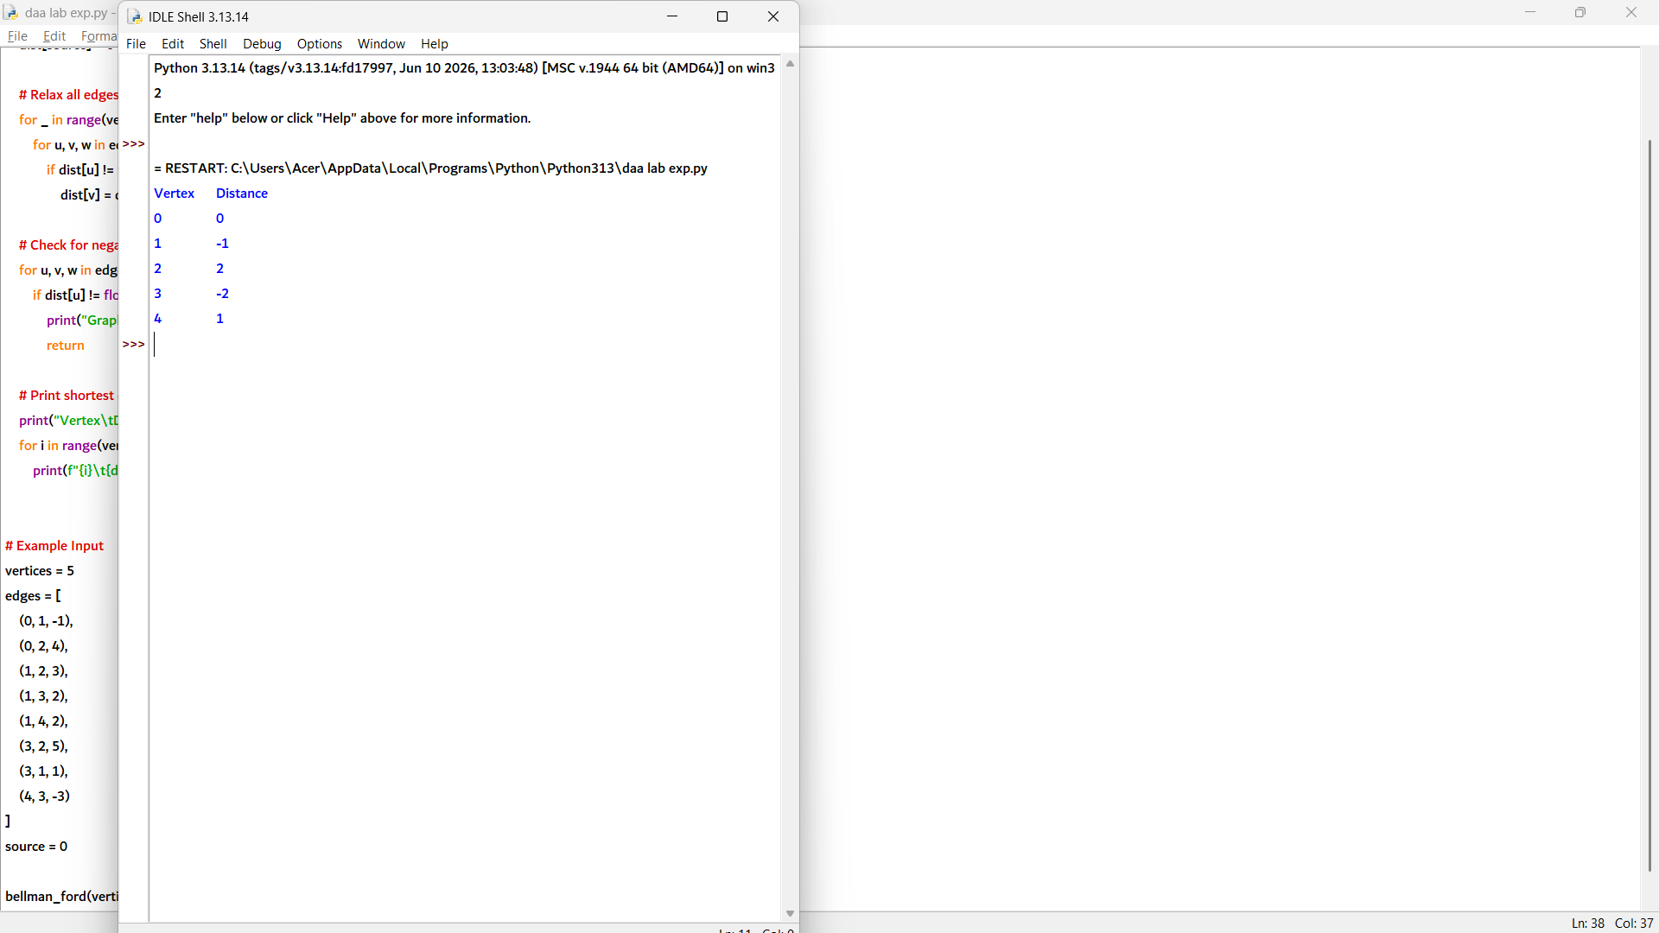

2. INF = float('inf')

def floyd_warshall(graph):
n = len(graph)

# Copy the graph into a distance matrix
dist = [row[:] for row in graph]

# Update shortest distances
for k in range(n):
for i in range(n):
for j in range(n):
if dist[i][k] != INF and dist[k][j] != INF:
dist[i][j] = min(
dist[i][j],
dist[i][k] + dist[k][j]
)

return dist

# Example 1
graph = [
[0, 5, INF, 10],
[INF, 0, 3, INF],
[INF, INF, 0, 1],
[INF, INF, INF, 0]
]

result = floyd_warshall(graph)

print("Shortest Distance Matrix:")
for row in result:
print(row)

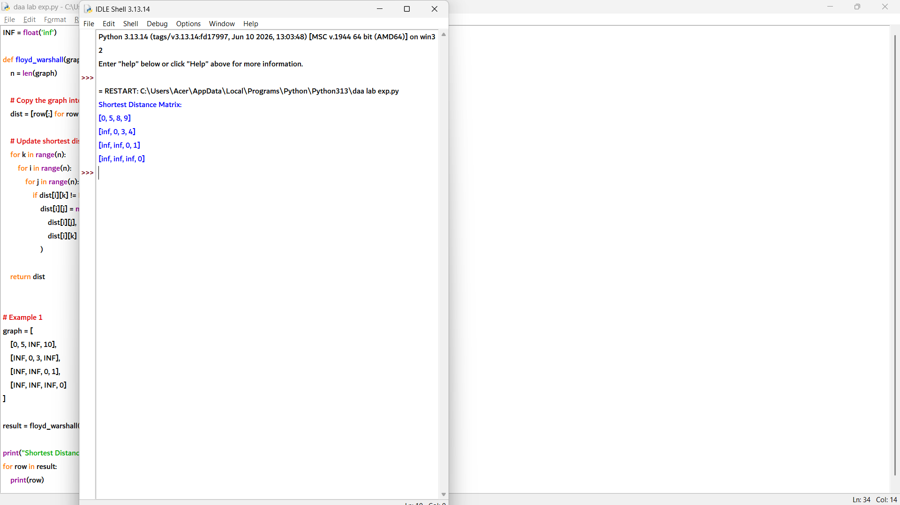

3. def warshall(graph):
n = len(graph)

# Copy the adjacency matrix
closure = [row[:] for row in graph]

# Warshall's Algorithm
for k in range(n):
for i in range(n):
for j in range(n):
closure[i][j] = (
closure[i][j] or
(closure[i][k] and closure[k][j])
)

return closure

# Example 1
graph1 = [
[0, 1, 0, 0],
[0, 0, 1, 0],
[0, 0, 0, 1],
[0, 0, 0, 0]
]

result1 = warshall(graph1)

print("Transitive Closure:")
for row in result1:
print(row)

# Example 2
graph2 = [
[0, 1, 1],
[0, 0, 1],
[1, 0, 0]
]

result2 = warshall(graph2)

print("\nTransitive Closure:")
for row in result2:
print(row)

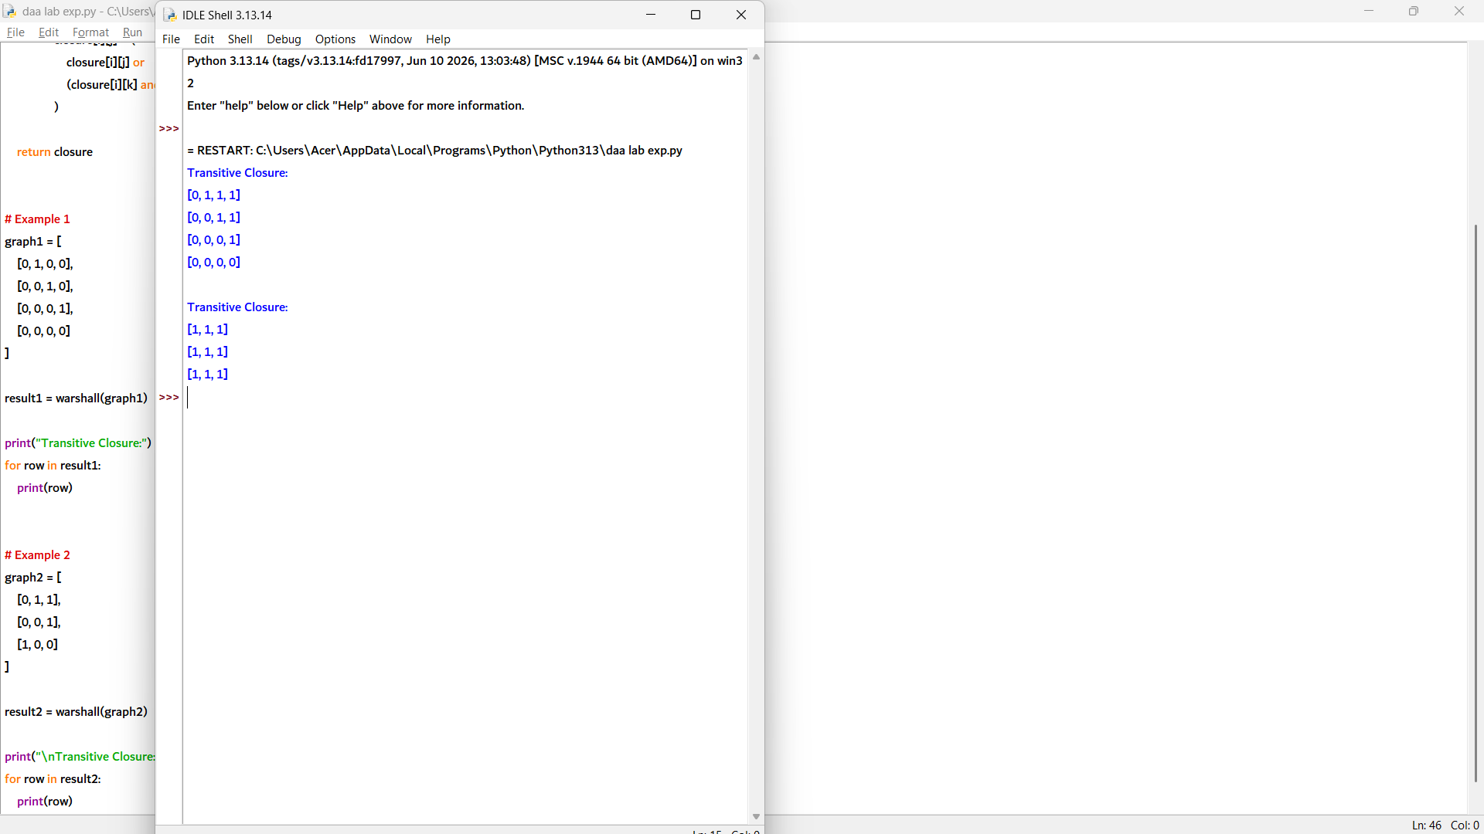

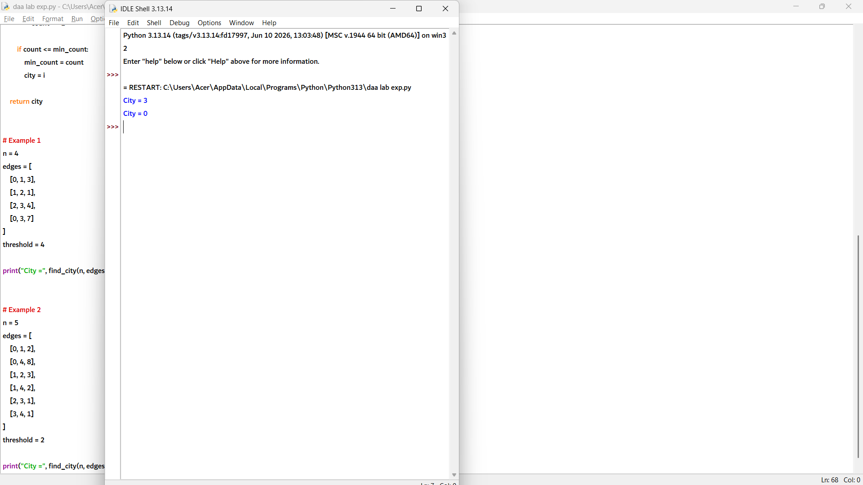

5. def network_delay_time(times, n, k):
INF = float('inf')

# Initialize distances
dist = [INF] * (n + 1)
dist[k] = 0

# Bellman-Ford relaxation
for _ in range(n - 1):
updated = False

for u, v, w in times:
if dist[u] != INF and dist[u] + w < dist[v]:
dist[v] = dist[u] + w
updated = True

if not updated:
break

# Check if all nodes are reachable
max_time = 0

for i in range(1, n + 1):
if dist[i] == INF:
return -1
max_time = max(max_time, dist[i])

return max_time

# Example 1
times = [
[2, 1, 1],
[2, 3, 1],
[3, 4, 1]
]
n = 4
k = 2

print("Network Delay Time =", network_delay_time(times, n, k))

# Example 2
times = [
[1, 2, 1]
]
n = 2
k = 2

print("Network Delay Time =", network_delay_time(times, n, k))

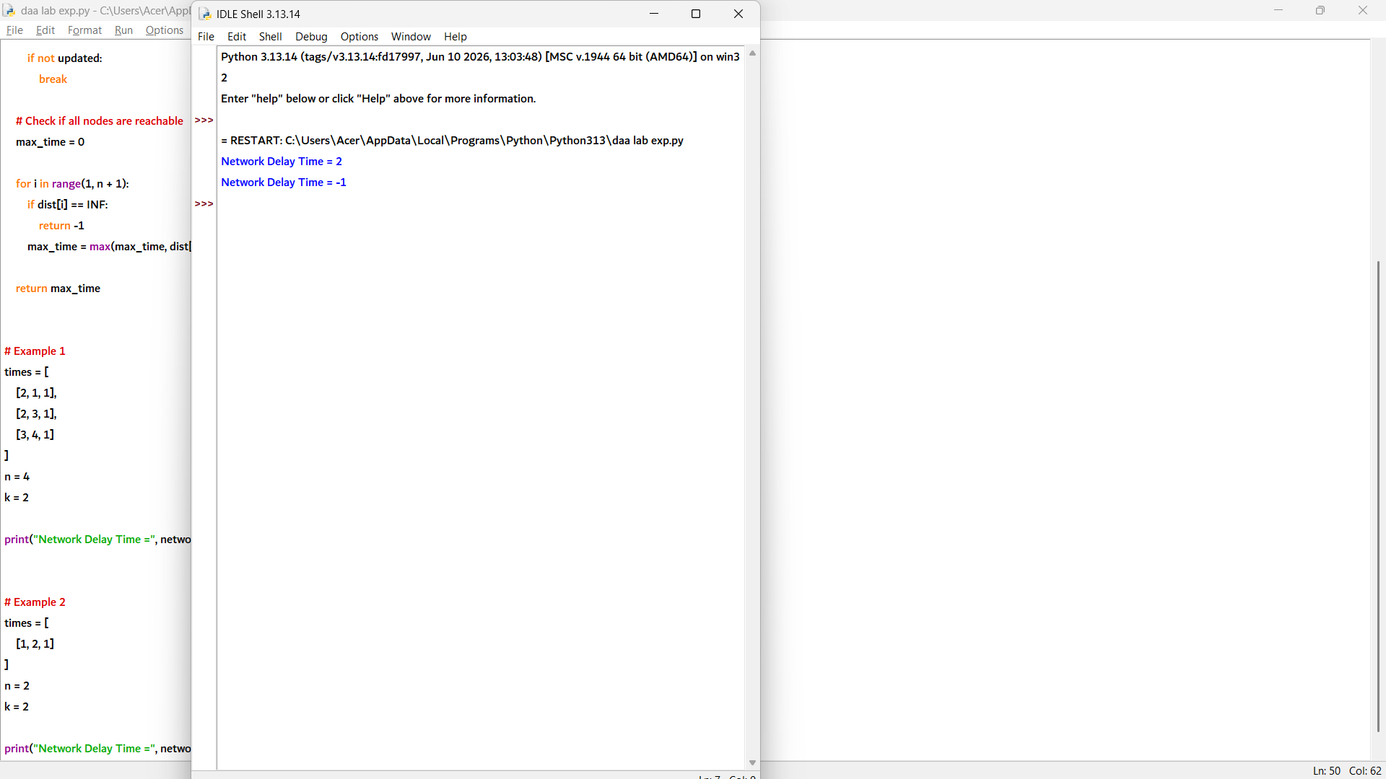

6. def cheapest_flight(n, flights, src, dst, K):
INF = float('inf')

# Distance array
dist = [INF] * n
dist[src] = 0

# Relax edges only K+1 times (number of flights allowed)
for _ in range(K + 1):
temp = dist[:]

for u, v, cost in flights:
if dist[u] != INF and dist[u] + cost < temp[v]:
temp[v] = dist[u] + cost

dist = temp

# If destination is unreachable
return -1 if dist[dst] == INF else dist[dst]

# Example 1
n = 4
flights = [
[0, 1, 100],
[1, 2, 100],
[2, 3, 100],
[0, 3, 500]
]
src = 0
dst = 3
K = 1

print("Cheapest Cost =", cheapest_flight(n, flights, src, dst, K))

# Example 2
n = 4
flights = [
[0, 1, 100],
[1, 2, 100],
[2, 3, 100],
[0, 3, 500]
]
src = 0
dst = 3
K = 2

print("Cheapest Cost =", cheapest_flight(n, flights, src, dst, K))

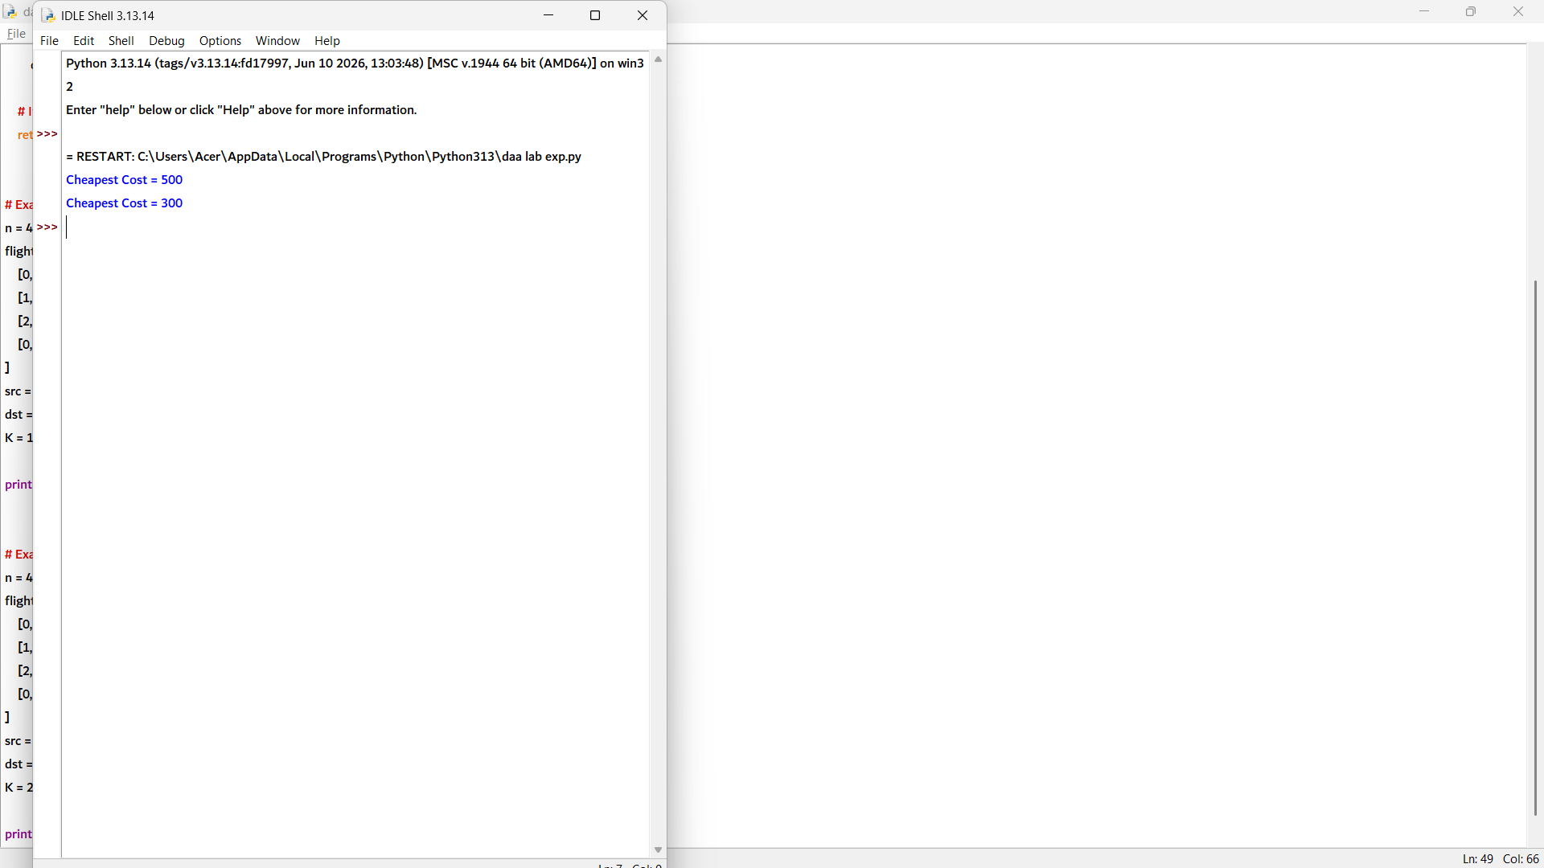

7. def detect_negative_cycle(vertices, edges):
# Initialize distances
dist = [0] * vertices

# Relax all edges V-1 times
for _ in range(vertices - 1):
for u, v, w in edges:
if dist[u] + w < dist[v]:
dist[v] = dist[u] + w

# Check for negative weight cycle
for u, v, w in edges:
if dist[u] + w < dist[v]:
return True

return False

# Example 1
vertices = 4
edges = [
(0, 1, 1),
(1, 2, -1),
(2, 3, -1),
(3, 0, -1)
]

if detect_negative_cycle(vertices, edges):
print("Negative Weight Cycle Exists")
else:
print("No Negative Weight Cycle")

# Example 2
vertices = 4
edges = [
(0, 1, 4),
(0, 2, 5),
(1, 2, -2),
(2, 3, 3)
]

if detect_negative_cycle(vertices, edges):
print("Negative Weight Cycle Exists")
else:
print("No Negative Weight Cycle")

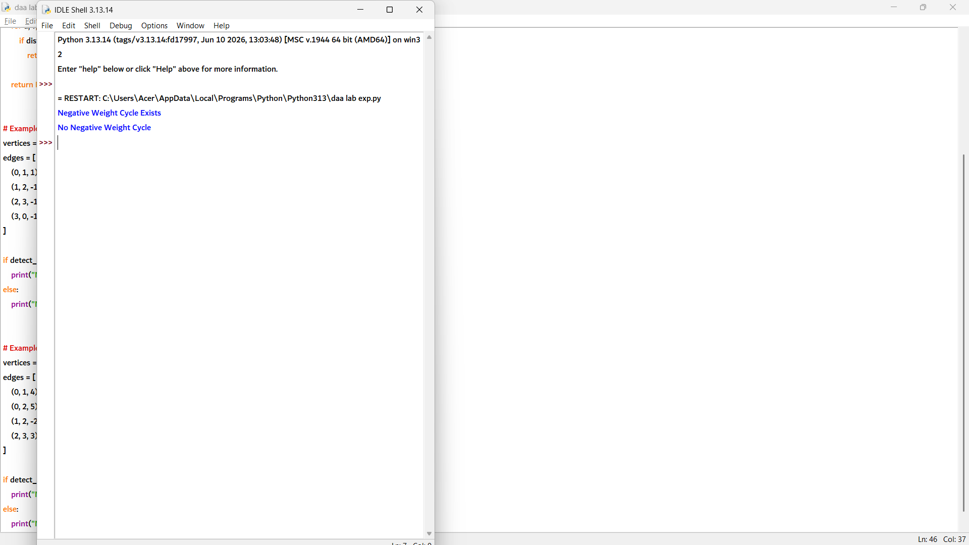

8. def warshall_reachability(graph, u, v):
n = len(graph)

# Copy graph to transitive closure matrix
closure = [row[:] for row in graph]

# Warshall's Algorithm
for k in range(n):
for i in range(n):
for j in range(n):
closure[i][j] = (
closure[i][j] or
(closure[i][k] and closure[k][j])
)

# Check path existence
if closure[u][v]:
return "Path Exists"
else:
return "Path Does Not Exist"

# Example 1
graph1 = [
[0, 1, 0],
[0, 0, 1],
[0, 0, 0]
]

print(warshall_reachability(graph1, 0, 2))

# Example 2
graph2 = [
[0, 1, 0],
[0, 0, 0],
[1, 0, 0]
]

print(warshall_reachability(graph2, 1, 2))

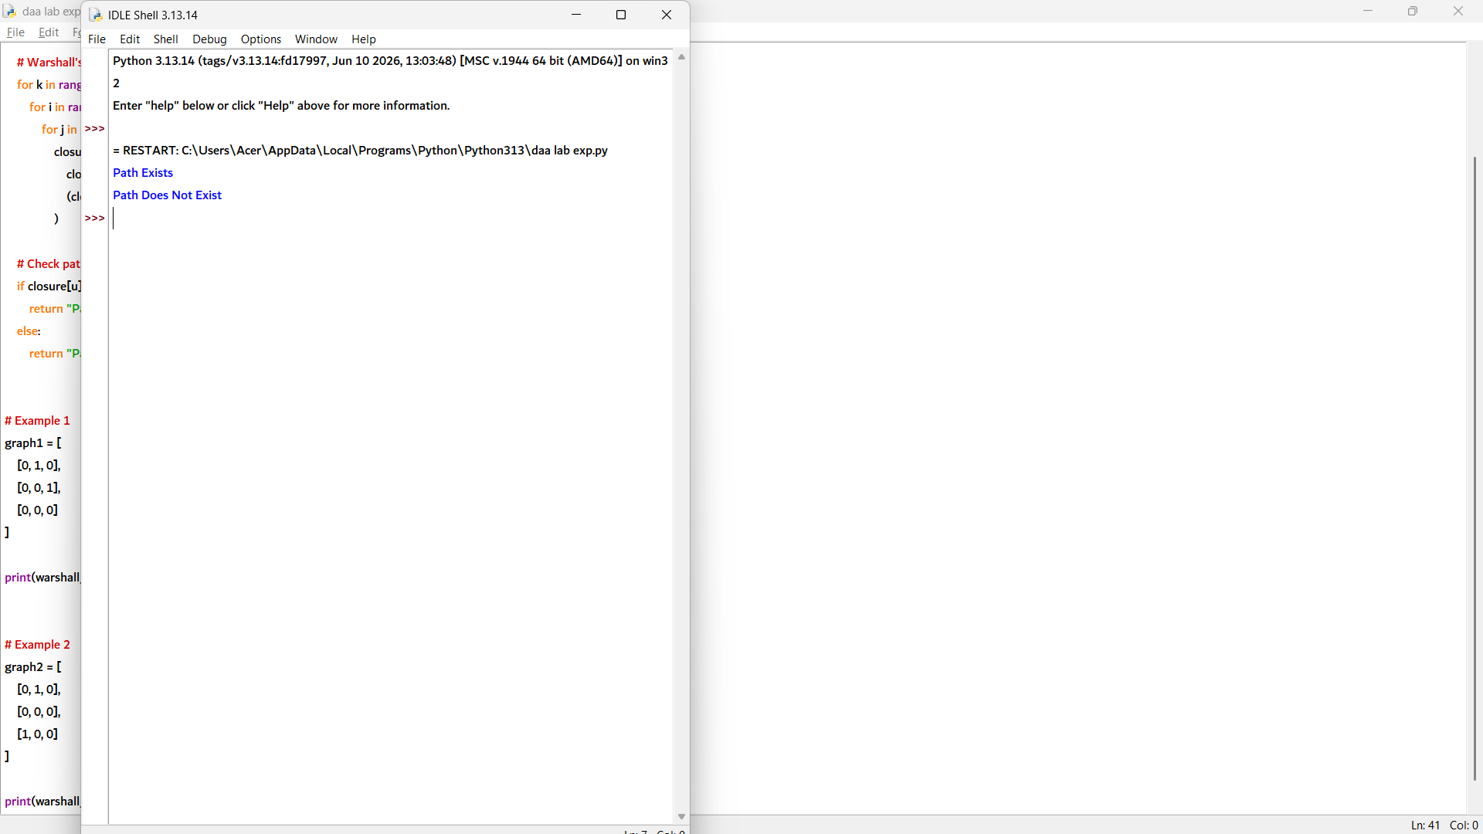

9. def count_reachable(graph, source):
n = len(graph)

# Copy graph to create transitive closure matrix
closure = [row[:] for row in graph]

# Warshall's Algorithm
for k in range(n):
for i in range(n):
for j in range(n):
closure[i][j] = (
closure[i][j] or
(closure[i][k] and closure[k][j])
)

# Count reachable vertices excluding source
count = 0
for i in range(n):
if i != source and closure[source][i]:
count += 1

return count

# Example 1
graph1 = [
[0, 1, 0, 0],
[0, 0, 1, 0],
[0, 0, 0, 1],
[0, 0, 0, 0]
]

print(count_reachable(graph1, 0))

# Example 2
graph2 = [
[0, 1, 1],
[0, 0, 1],
[1, 0, 0]
]

print(count_reachable(graph2, 1))

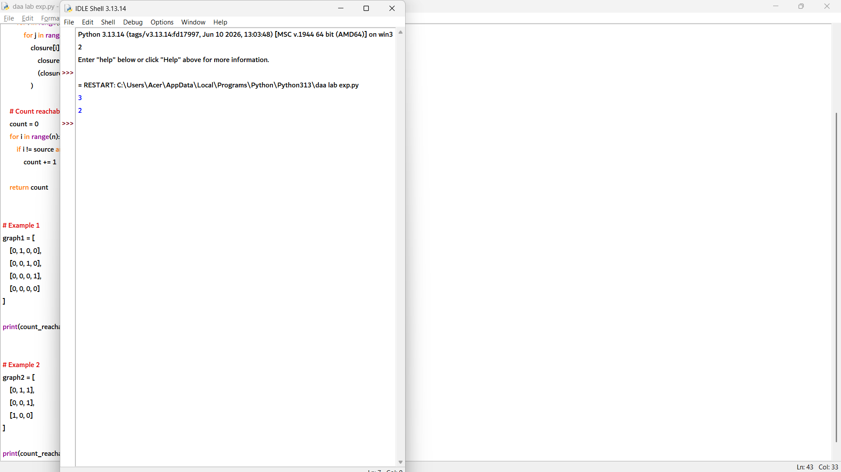

10. def graph_diameter(graph):
n = len(graph)
INF = float('inf')

# Copy graph to distance matrix
dist = [row[:] for row in graph]

# Floyd-Warshall Algorithm
for k in range(n):
for i in range(n):
for j in range(n):
if dist[i][k] != INF and dist[k][j] != INF:
dist[i][j] = min(
dist[i][j],
dist[i][k] + dist[k][j]
)

# Find maximum shortest path distance
diameter = 0

for i in range(n):
for j in range(n):
if dist[i][j] != INF:
diameter = max(diameter, dist[i][j])

return diameter

INF = float('inf')

# Example 1
graph1 = [
[0, 2, INF],
[2, 0, 3],
[INF, 3, 0]
]

print("Diameter =", graph_diameter(graph1))

# Example 2
graph2 = [
[0, 1, 4],
[1, 0, 2],
[4, 2, 0]
]

print("Diameter =", graph_diameter(graph2))

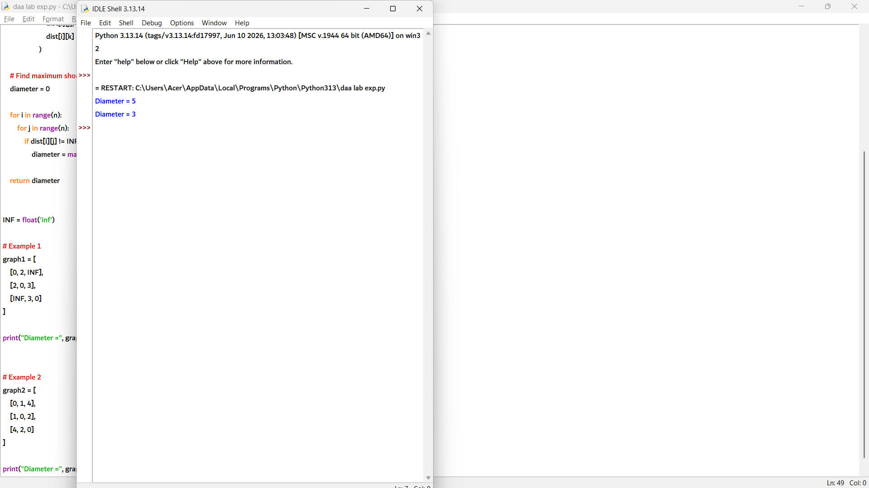

11. def shortest_distance(graph, u, v):
INF = float('inf')
n = len(graph)

# Copy graph to distance matrix
dist = [row[:] for row in graph]

# Floyd-Warshall Algorithm
for k in range(n):
for i in range(n):
for j in range(n):
if dist[i][k] != INF and dist[k][j] != INF:
dist[i][j] = min(
dist[i][j],
dist[i][k] + dist[k][j]
)

# Return shortest distance
return dist[u][v]

INF = float('inf')

# Example 1
graph1 = [
[0, 3, INF, 7],
[8, 0, 2, INF],
[5, INF, 0, 1],
[2, INF, INF, 0]
]

print("Shortest Distance =", shortest_distance(graph1, 0, 3))

# Example 2
graph2 = [
[0, 4, INF],
[INF, 0, 6],
[2, INF, 0]
]

print("Shortest Distance =", shortest_distance(graph2, 2, 1))

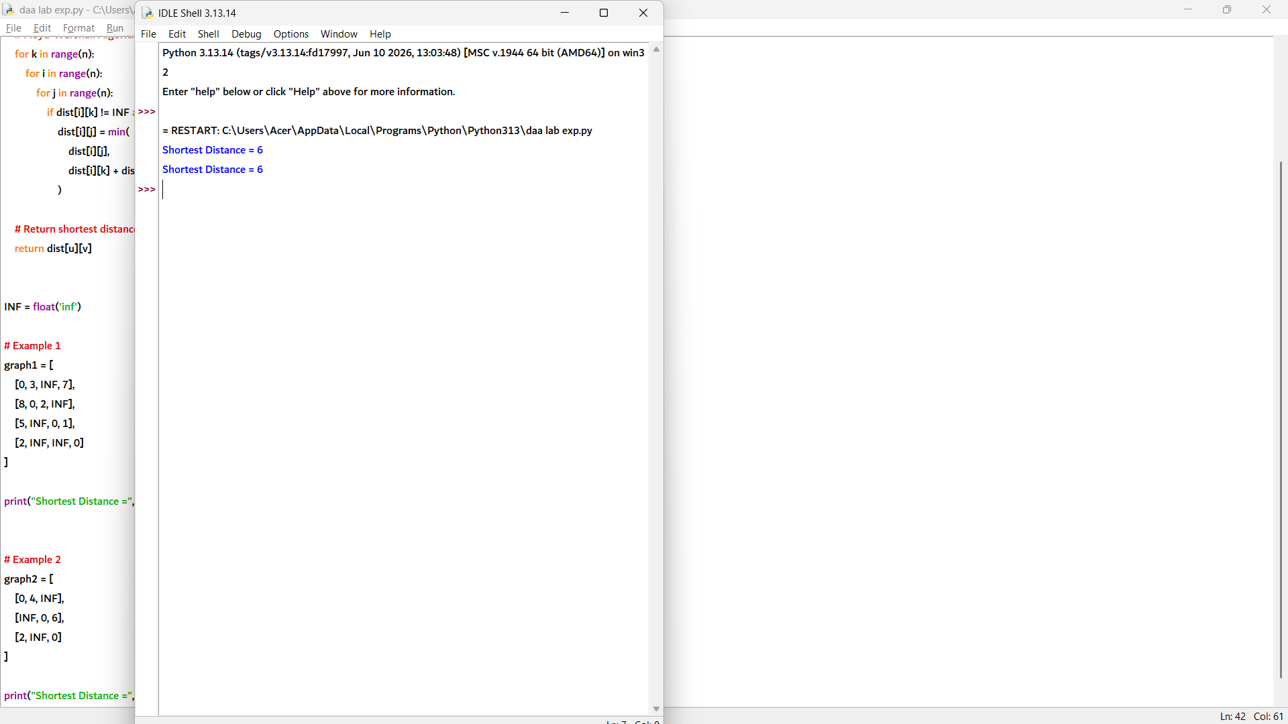

def find_vertex(graph):
n = len(graph)

# Create transitive closure matrix
closure = [row[:] for row in graph]

# Warshall's Algorithm
for k in range(n):
for i in range(n):
for j in range(n):
closure[i][j] = (
closure[i][j] or
(closure[i][k] and closure[k][j])
)

# Find smallest indexed vertex reachable from all others
for v in range(n):
reachable = True

for i in range(n):
if i != v and closure[i][v] == 0:
reachable = False
break

if reachable:
return v

return -1

# Example 1
graph1 = [
[0, 1, 1],
[0, 0, 1],
[0, 0, 0]
]

print(find_vertex(graph1))

# Example 2
graph2 = [
[0, 1, 0],
[0, 0, 1],
[1, 0, 0]
]

print(find_vertex(graph2))

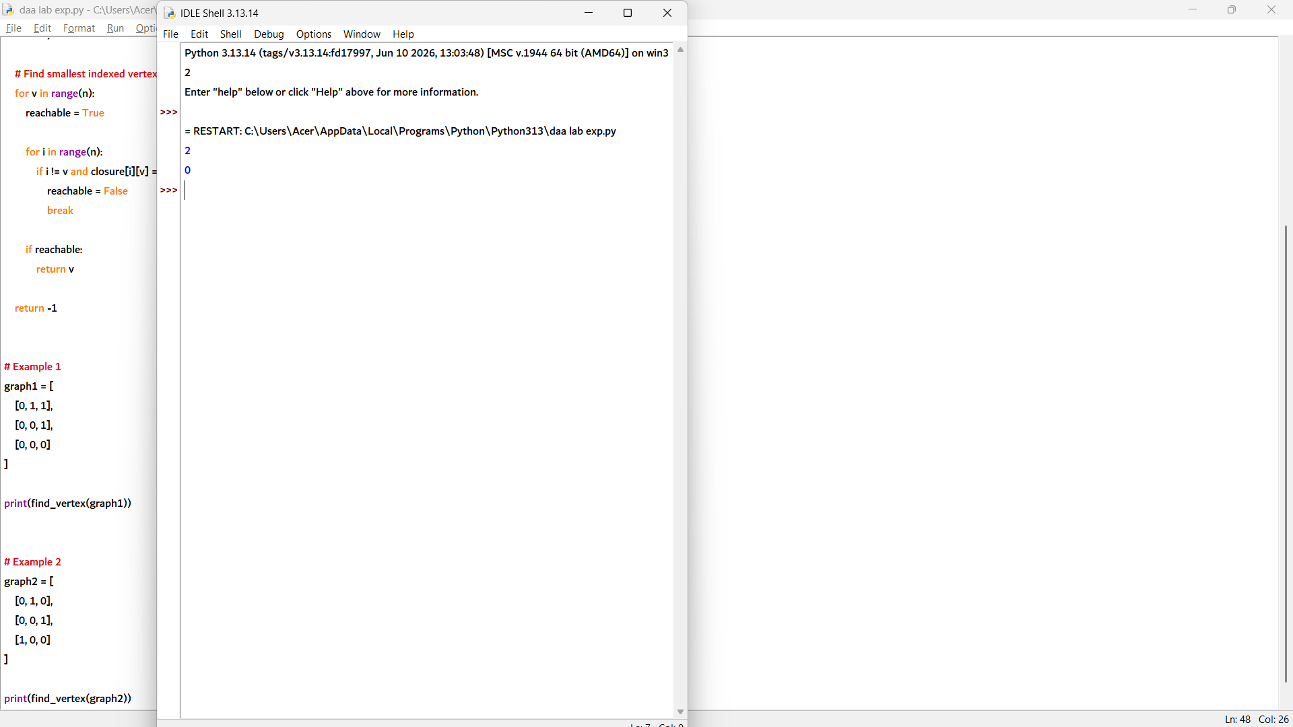

13. def max_reachable_vertex(graph):
n = len(graph)

# Create transitive closure matrix
closure = [row[:] for row in graph]

# Warshall's Algorithm
for k in range(n):
for i in range(n):
for j in range(n):
closure[i][j] = (
closure[i][j] or
(closure[i][k] and closure[k][j])
)

# Find vertex with maximum reachable vertices
max_count = -1
vertex = -1

for i in range(n):
count = 0

for j in range(n):
if i != j and closure[i][j]:
count += 1

# Tie automatically keeps smaller index
if count > max_count:
max_count = count
vertex = i

return vertex

# Example 1
graph1 = [
[0, 1, 1, 0],
[0, 0, 1, 0],
[0, 0, 0, 1],
[0, 0, 0, 0]
]

print(max_reachable_vertex(graph1))

# Example 2
graph2 = [
[0, 1, 0],
[0, 0, 1],
[1, 0, 0]
]

print(max_reachable_vertex(graph2))

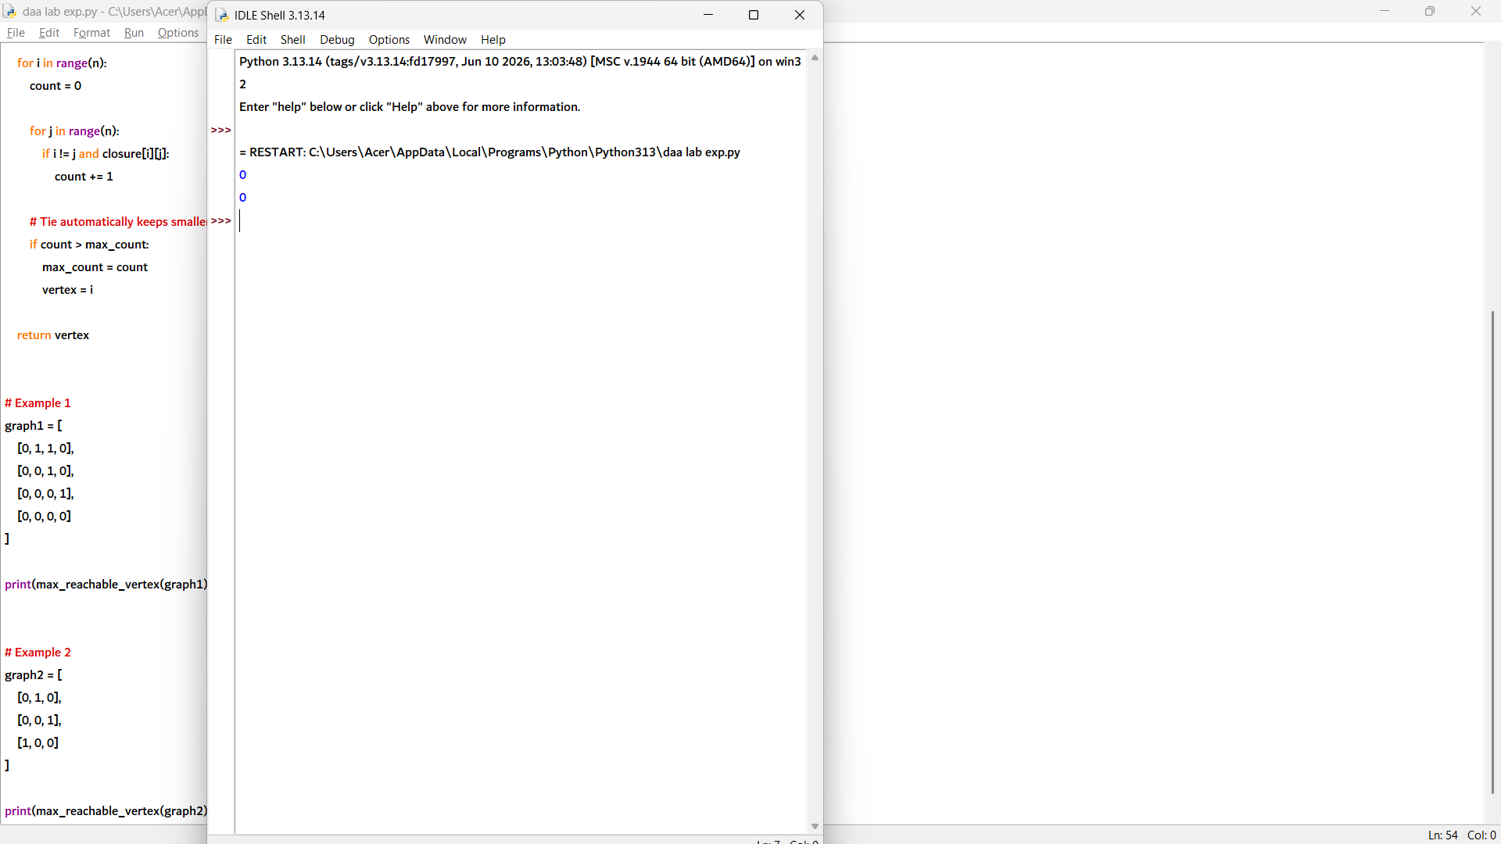

14. def graph_diameter(graph):
n = len(graph)
INF = float('inf')

# Copy graph to distance matrix
dist = [row[:] for row in graph]

# Floyd-Warshall Algorithm
for k in range(n):
for i in range(n):
for j in range(n):
if dist[i][k] != INF and dist[k][j] != INF:
dist[i][j] = min(
dist[i][j],
dist[i][k] + dist[k][j]
)

# Find maximum shortest path distance
diameter = 0

for i in range(n):
for j in range(n):
if dist[i][j] != INF:
diameter = max(diameter, dist[i][j])

return diameter

INF = float('inf')

# Example 1
graph1 = [
[0, 2, INF],
[2, 0, 4],
[INF, 4, 0]
]

print("Diameter =", graph_diameter(graph1))

# Example 2
graph2 = [
[0, 1, 5],
[1, 0, 2],
[5, 2, 0]
]

print("Diameter =", graph_diameter(graph2))

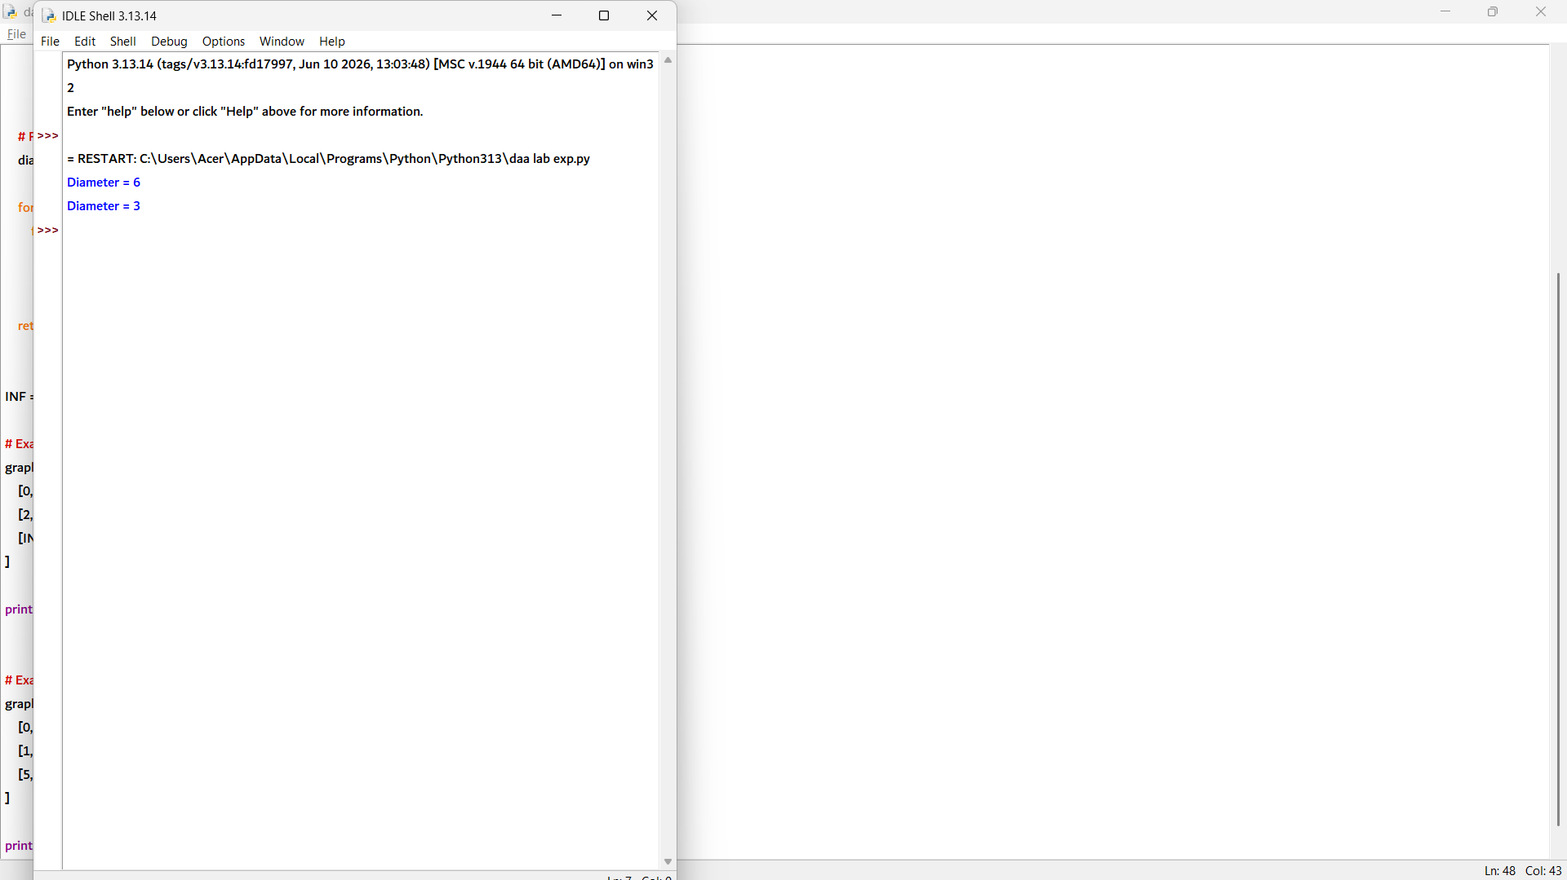

15. def is_strongly_connected(graph):
n = len(graph)

# Create transitive closure matrix
closure = [row[:] for row in graph]

# Warshall's Algorithm
for k in range(n):
for i in range(n):
for j in range(n):
closure[i][j] = (
closure[i][j] or
(closure[i][k] and closure[k][j])
)

# Check if every vertex can reach every other vertex
for i in range(n):
for j in range(n):
if i != j and closure[i][j] == 0:
return "Not Strongly Connected"

return "Strongly Connected"

# Example 1
graph1 = [
[0, 1, 0],
[0, 0, 1],
[1, 0, 0]
]

print(is_strongly_connected(graph1))

# Example 2
graph2 = [
[0, 1, 0],
[0, 0, 1],
[0, 0, 0]
]

print(is_strongly_connected(graph2))

